ABNL DEBRIEFING ACTIVITIES | 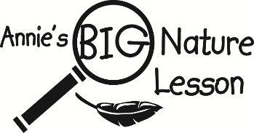
Concentric Circles  After an expert lesson, invite students to write a numbered list of things they learned. This can be big ideas, details, or facts—a quick list of things they remember from the lesson. Next, arrange half of the students in a circle, facing outward, and the other half of the students facing them, thus forming an inside and an outside circle. Beginning with the inside circle, students use their lists and tell their circle partner ONE of the things on the list. This gets the conversation started, and both partners talk. Ring a bell and instruct the outside circle to move to the next person, and then the outside person begins by telling one thing to the new partner. Continue until students have gone all the way around the circle.  This activity can also be done with two lines of children facing each other.  Walk and Talk  Pair students for this activity—give them a designated area to walk and talk with their partner, reviewing the expert lesson. This works well for walking around a field, the perimeter of a classroom, etc.  Think—Pair—Share  Ask a challenging or open-ended question to students, and give them a minute to think about the question. Students then pair with a classmate sitting nearby and discuss their ideas about the question for several minutes.  Three Sentence Wrap-Up  Invite students to summarize the expert lesson by writing three sentences. Then pair students to read their sentences to a classmate.  Wonder Wall with Post-It Notes  Hang a large sheet of paper on the wall—labeling two columns “Ah-ha” and “Appreciation”. Invite students to write their “Ah-ha’s” (new learning) on the post-it notes, one idea on each note. Do the same for “Appreciation” so that children have a chance to say and write what they appreciated about way the scientist or naturalist taught the lesson.  This post-it note activity also works well after a lesson or walk with these categories: “Observations” and “Wonder” or “Wonderful” and “I Wonder”—with Observations or Wonderful including all that children had seen or heard, and Wonder including questions about the tour.  The Forest vs. the Trees  Explain the concept of “the forest and the trees” to students—BIG ideas/concepts vs. facts/details. Invite students to review the expert lesson by brainstorming a list of the details they learned. Then guide the students in a discussion about grouping the details into categories. Finally, invite students to label categories with titles—those titles then become the big ideas or concepts of the expert lesson. Another version of this activity: teacher guides students to make a 2-column list. Teacher demonstrates by listing main ideas in the first column, then inviting students to copy the main ideas, and then in the second column, list the details that they learned.  Parent-led Small Groups  Invite parents to meet with small groups of students for discussion. Give parents a time frame for this discussion, and ask them to fill the time by engaging ALL of the students to participate. At the designated time, ask each small group to report back to whole group about their discussion.  Questions and (maybe) Answers  After an expert lesson, invite students to generate a list of questions—just questions, without the focus on getting answers. Post the following question starters so that students can direct their questions to the content of the expert lesson.  Five Senses Carousel Activity  Title large sheets of paper with each of the five senses. Split students into five small groups and give them a few minutes at each station to write down ideas about what they remembered from the expert lesson. This is a quick activity—allow just a few minutes for each sheet.  Chart Paper Splash—whole class  Teacher invites students to call out ideas, facts, and details from the expert lesson. This is a collective effort of the entire class. Students often like to make this list as long as they can!  Chart Paper Splash—small groups  Same activity, but with one large sheet of paper for each small group of students. Students work together to make this list, and then when the allotted time is up, the chart paper from each group is posted. Students are then invited to look at the lists from the other groups, noticing the similarities and differences.  Three Questions Activity  After an expert lesson, invite students to write responses to these three questions:  (1) What did I learn?  (2) What are my questions?  (3) How is this connected to my life?  Expanding on these questions:  (1) What big ideas did I learn? What did we do?  (2) What do I wonder, now that I’ve done this lesson?  (3) How does this lesson relate to ME? Who else in my life would like to learn this lesson?  Four Square Conclusions  After an expert lesson, invite students to split the page into four squares. In the first squares, students can write the main ideas or conclusions about what was learned. Then after this short writing time, students visit with three classmates, find out about their ideas, and write in each square. Be careful to tell students that they will write in their own journals, thus strengthening their listening skills.  Quick Draws  After an expert lesson, teacher lists several vocabulary words from the lesson on the board. Students then draw a picture to demonstrate their understanding of the word, based on their new learning.  Teacher-led Review  Immediately after an expert lesson and BEFORE beginning a “Question and Answer” time for the speaker, ask students to think about the most important things they learned about the lesson. Ask students to think about this: What do you know now that you didn’t know before? Ask students to recall the facts that they learned, and to think about the information from the lesson. After allowing some time for thinking, then call on students to tell what they remembered/learned from the lesson. After this review, then open the discussion for questions from the students to the speaker.  Whiteboard Hold-Ups  Teacher uses individual student whiteboards for review of expert lesson. Whiteboards can be laminated construction paper, or plastic disposable plates, and can be written on with dry-erase markers for easy writing and erasing.  K-W-L-M  Before an expert lesson, ask students to ponder these questions: What do I know? What do I want to learn? After the lesson, invite students to write about these questions: What have I learned? What more do I want to learn? | 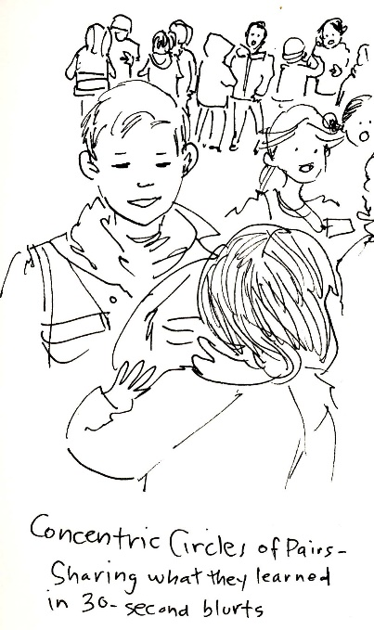  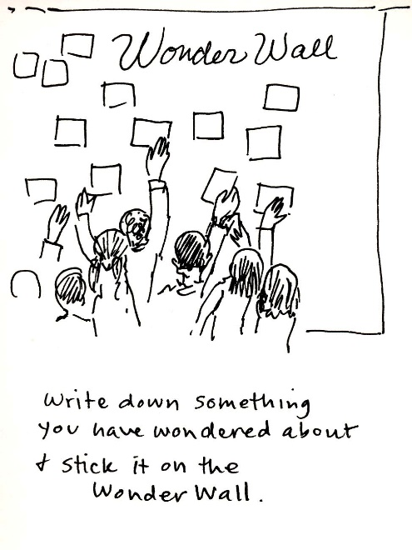  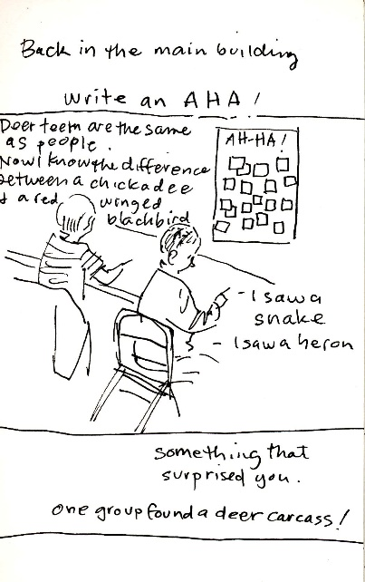  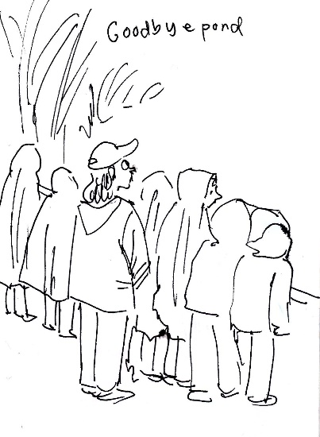  Artwork by Ruth McNally Barshaw ©2006  Ruthexpress.com

